**How to install/configure IIS 8.5, CGI and Metabase Components for Windows 2012**

**Document ID:**  TEC1584216  
**Last Modified Date:**  09/16/2015   
[Show Technical Document Details](https://www.ca.com/us/services-support/ca-support/ca-support-online/knowledge-base-articles.TEC1584216.html)

**Description**

When installing or configuring CA Service Desk Manager (CA SDM) in a Windows 2012 environment, one may encounter a problem in trying to select any of the webengine options that includes IIS.

For example, in the following graphic, one can access the Config Type in pdm_configure, but only choose "Tomcat Server only" and none of the IIS options:

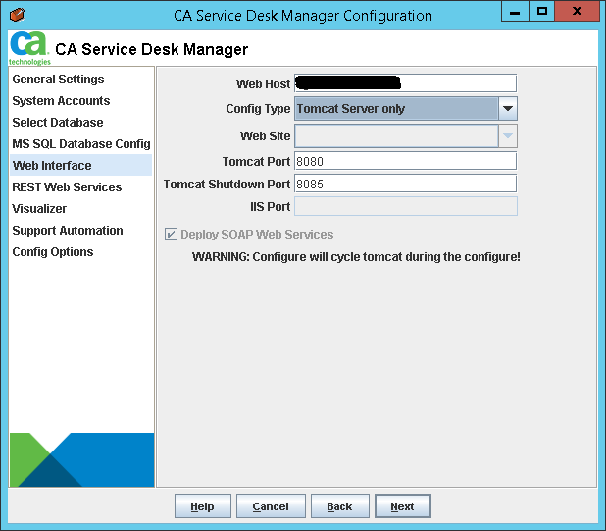

By default, Windows 2012 does not include IIS 8.5 and it needs to be installed and configured to include the CGI and Metabase components.  This document discusses how to setup IIS 8.5 so that one can have CA SDM work with IIS as an available webengine.

**Solution**

**Note:  These instructions require you to login as a local system administrator to the Windows 2012 server and assume that IIS is not installed at all.**

**The following instructions may also require the following:**

* **Assistance from a Network or Systems Administrator**
* **Windows 2012 Server Install Media**
* **A full recycle of the Windows Server**

1. On the Windows 2012 Server, go into the Administrative Tools (Control Panel -> System and Security) and access "Server Manager"  
   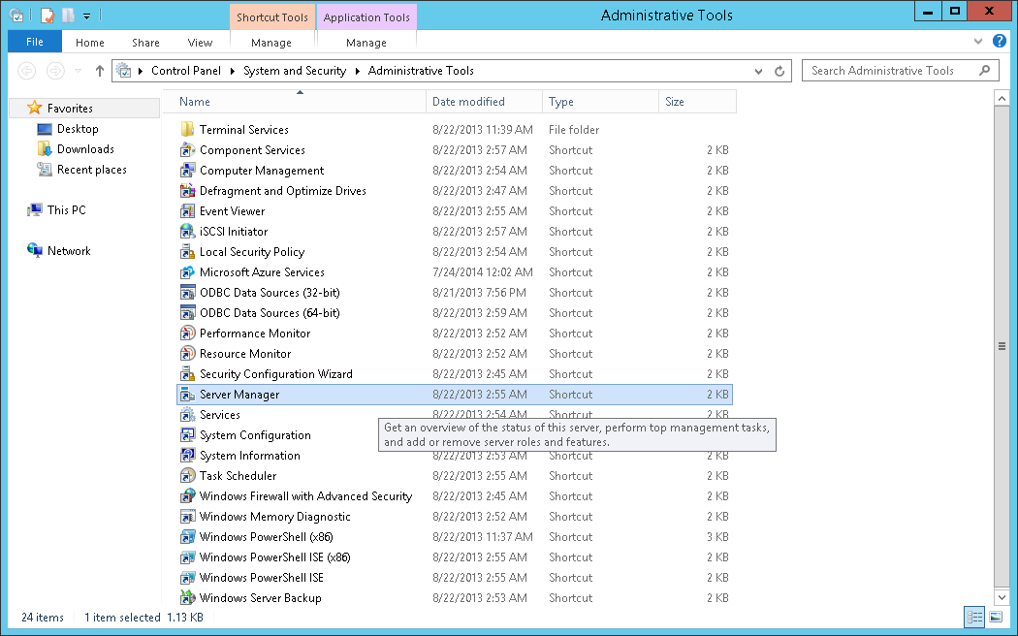
2. Once in Server Manager, choose "Add roles and features".  
   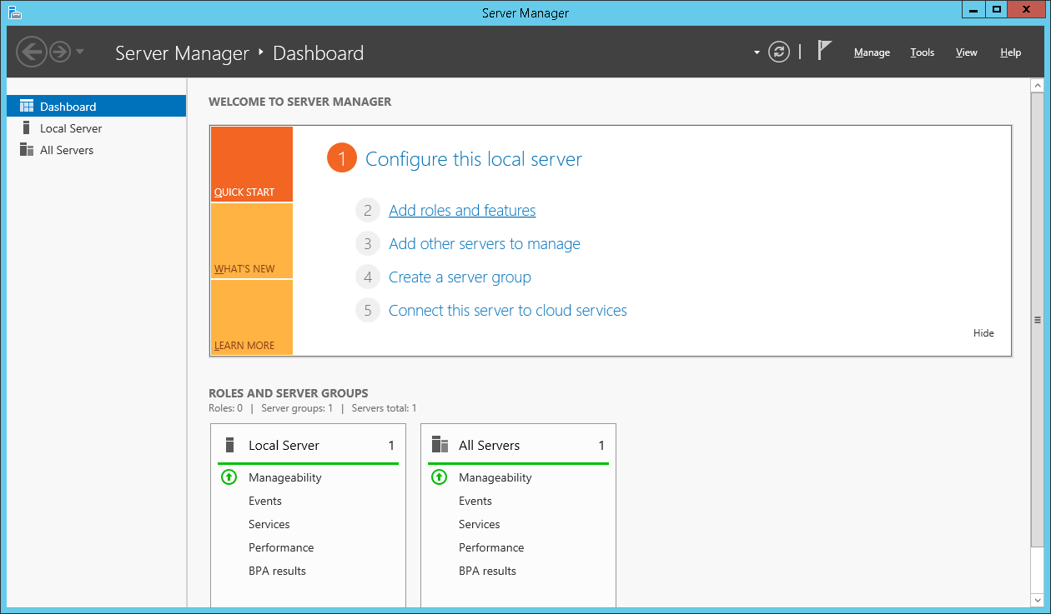
3. In the "Add Roles and Features Wizard", click "Next" and answer any questions regarding your environment with the defaults.  Make sure you are configuring for updates on your local system.  Continue until you reach "Server Roles".
4. Once you reach "Server Roles", click on "Web Server (IIS)" and check it ON, then click Next.  
   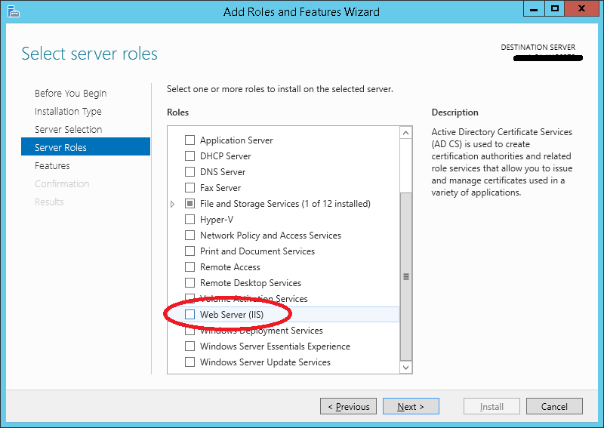
5. You will receive a message advising to "Add features that are required for Web Server (IIS)".  Make sure "Include management tools (if applicable)" is checked ON, then click "Add Features".  
   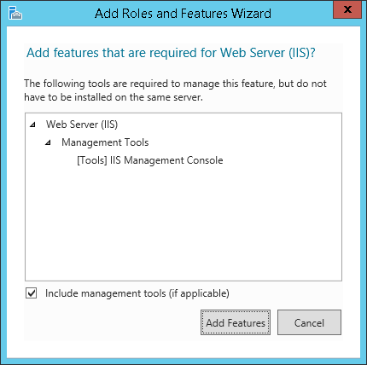
6. Continue through the wizard and answer any questions regarding your environment with the defaults.  Continue until you reach "Web Server Role (IIS) -> Role Services."
7. Check on the following:  "Management Tools", "IIS Management Console", "IIS 6 Management Compatibility", "IIS 6 Metabase Compatibility".  Click "Next".  
   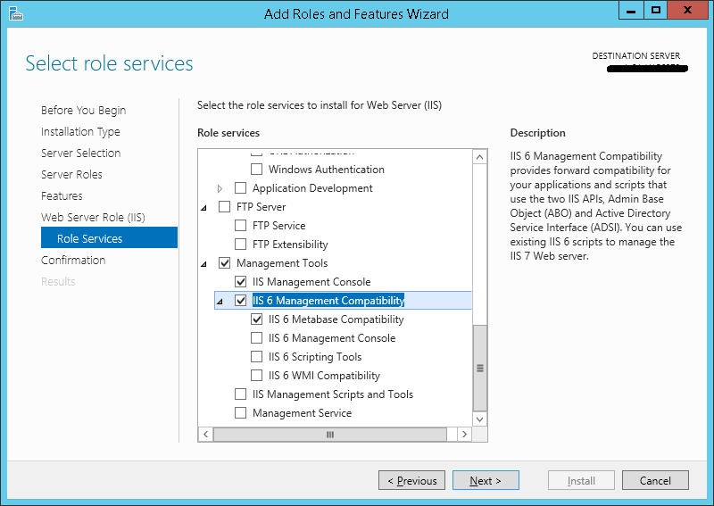
8. Accept the confirmation and proceed with the install.  After some time, a message similar to the following will be seen:  
   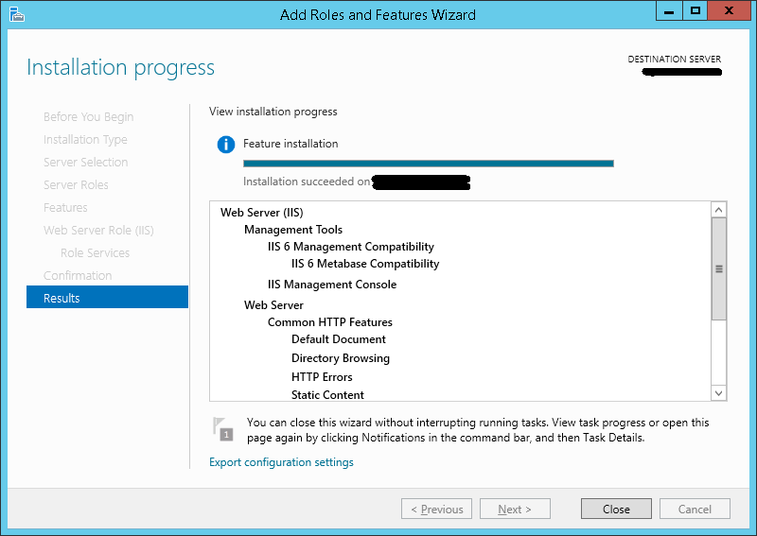
9. Go back into the Server Manager, choose "Add roles and features" again, and continue through the wizard as before, until you reach "Server Roles".
10. Scroll down and select/open "Web Server (IIS)" and install "Application Development" and "CGI"  
    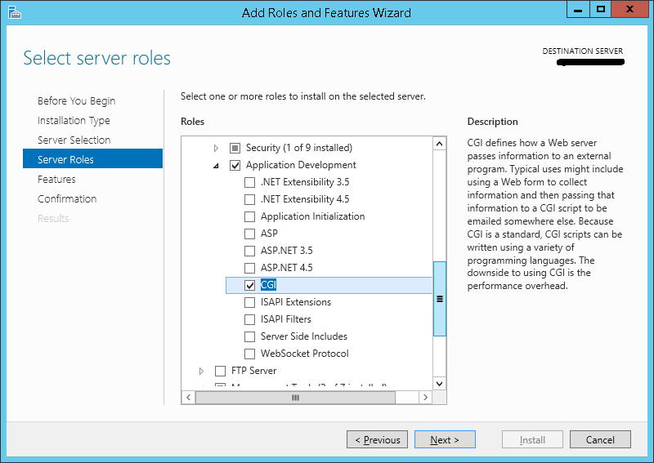  
    Note:  This was not possible earlier as IIS was not yet installed.  Once IIS has been installed (Steps #1-8), need to go back and select CGI in the IIS setup.
11. Continue through the wizard, until you reach the "Confirmation" page, which will look like this:  
    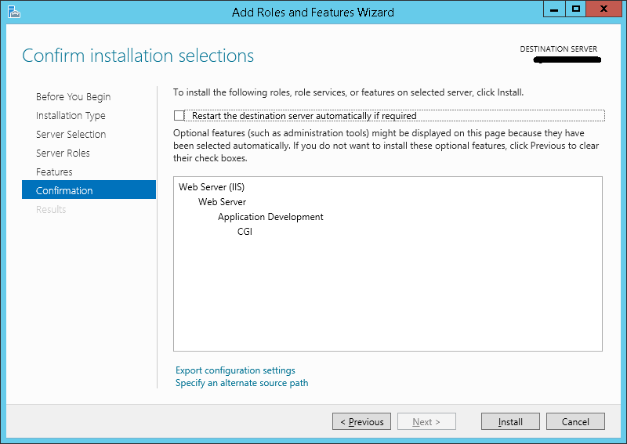  
    Make sure you have chosen the checkbox "Restart the destination server automatically if required".  Also make sure you are able to perform a recycle at this time.  Click "Install"
12. Once the IIS 8.5 component is installed, and the CGI and Metabase components are included, go into the Internet Information Services (IIS) Manager (under Administrative Tools).
13. Drill down on the left hand side of the window to access "Default Web Site", then choose "Header Mappings" on the right hand side of the window.  
    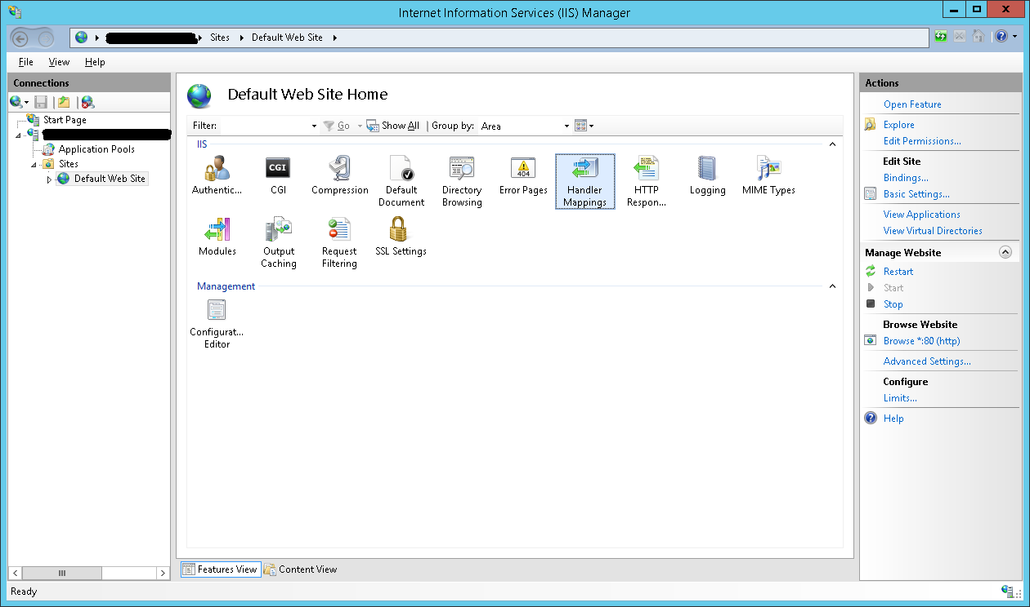
14. CGI-exe is disabled by default.  Right click on CGI-exe and select "Edit Feature Permissions"
15. For the "Execute" check box, check it as ON, then hit "OK" to enable CGI-exe.  
    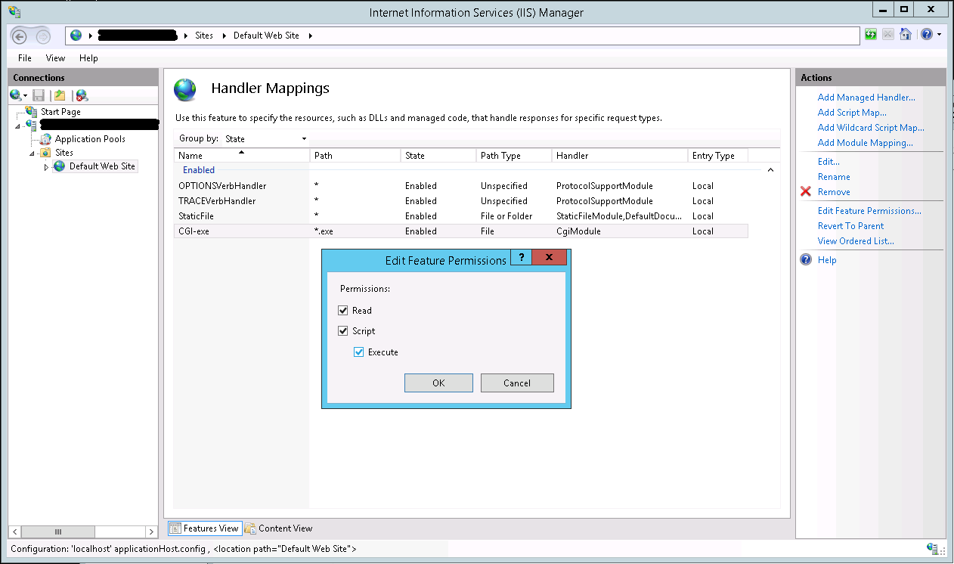

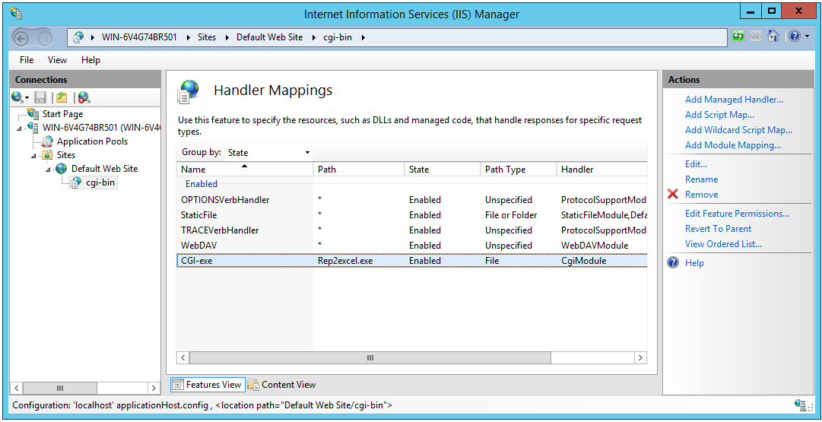

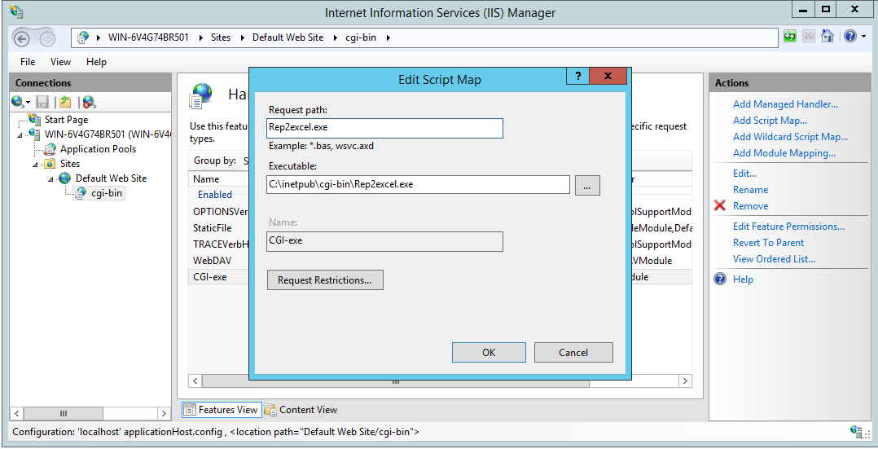

1. Recycle IIS.
2. You should now be able to access pdm_configure and select IIS as a choice for the web interface.  
   